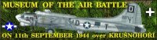  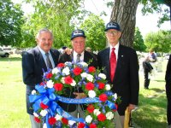  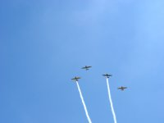  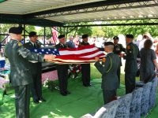  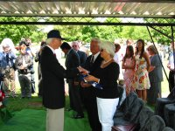  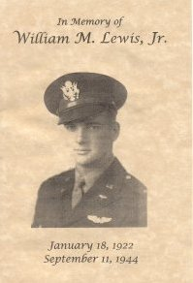  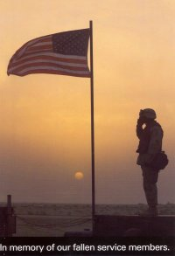  Charlie "Hong Kong" Wilson, Gayle Leonard, John Luckadoo (L-R) prior to the memorial service.  Hong Kong, Gayle and John at the wreath laying ceremony.  Missing man formation over the cemetery just prior to missing man split.  Folding the flag.  John Luckadoo presents the 100th Bomb Group flag to Sharon Cross, Lt. Lewis' daughter.  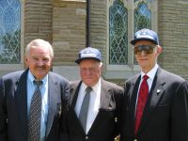  WE WILL NEVER FORGET! | Lt. William M. Lewis Comes Home  Based on an article in the May 29, 2004 issue of the Tulsa World  by Rob Martindale, World Senior Writer  Sharon Lewis Cross buried her father on Friday, and it was one of the happiest days of her life, closing a chapter dating back to 1944. Almost 60 years after he was shot from the skies over World War II Germany, Lt. William M. "Bill" Lewis, Jr. was laid to rest alongside his brother in his hometown of Tulsa. For years after the fighter pilot was shot down on Sept. 11, 1944, the family had no information on what had happened to his remains. After help at home and in Germany, the mystery was learned, and arrangements were completed to bring him home.  Bill Lewis was a P-51 pilot assigned to the 55th Fighter Group. On Sept. 11, 1944, the 55th was assigned to escort the 100th Bomb Group on a bombing mission to Ruhland, Germany. Short of the target, over Oberhof Germany, Lewis and others from his group were engaged by German fighters. The details of the loss are not known, but Lt.. Lewis'  P-51 was last seen nose-diving into a forest. It was one of 57 U.S. aircraft reported lost that day in one of the largest air battles of the European theater.  Lewis' plane was shot down in what later would become East Germany. His remains were found by German naturalist Adelbert Wolf, who buried them, marked the site with a cross and then tended to the grave site for decades. About a decade before the fall of the Berlin Wall, a U.S. delegation visited the area but was not allowed to exhume the remains.  Early in 2001, Ken Breaux, a Cross family friend, eventually made contact with  Jan Zdiarsky, a Czech aviation battle historian, and this contact led to the discovery  of Lt. Lewis' remains. Zdiarsky and Breaux both attended the memorial service.  Gayle Leonard, John Luckadoo, and Charlie "Hong Kong" Wilson, all 100th Bomb Group veterans attended the memorial service to honor the ultimate sacrifice Lt. Lewis made for the 100th. They laid a wreath on Lt. Lewis' grave and also presented a 100th Bomb Group flag to Lt. Lewis' daughter, Sharon Cross.  100th Bomb Group Crews Lost on the Ruhland Mission  2nd Lt. Charles E. Baker 2nd Lt. Hugh E. Holladay 1st Lt. Wesley R. Carlton 2nd Lt. Joseph H. Raine 2nd Lt. Paul E. Corley 1st Lt. Lawrence W. Riegel 1st Lt. Orville C. Everitt 2nd Lt. Howard R. Schulte 2nd Lt. John S. Giles, Jr. 2nd Lt. Harold R. Taylor 2nd Lt. Raymond L. Heironimus 1st Lt. Albert E. Trommer Read More About Ruhland Soden at Ruhland Ruhland Mission 9/11/44  Museum of the Air Battle over the Ore Mountains  http://www.100thbg.com/spotlight/lewis/lewis.htm

